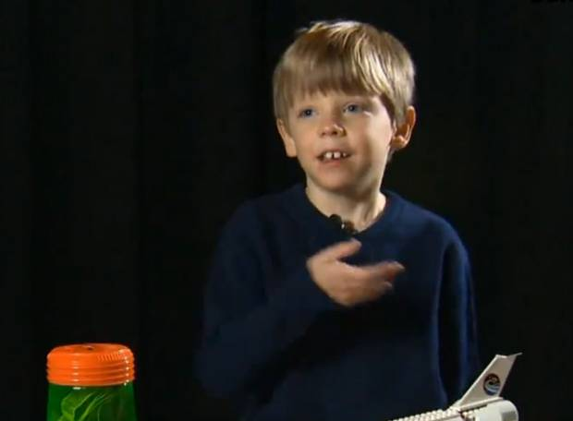
Ben
Figure 1 - "Yeah, but I made a Space Shuttle out of Lego"
- 10 years old
- Family
  - Mum
  - Dad
  - Older brother
- Not very competitive
- Smart
  - Top in classes
  - Likes to dress smart
  - Self-conscious about his teeth
- Tidy
- Organised
- Likes to make up a word and when people are taking a look in the dictionary, picks better pieces and replaces his own.

Jessie
- 22 years old
- Mum
  - Two Sons
    - 10
    - 15
  - Very close to husband
    - They both play scrabble often
- Extremely competitive
  - Cannot accept losing, demands a rematch if loses
Figure 2 - Motto - "You’re going to be a scrabbly mess on the floor!”
  - Plays to win, not to have fun
- OCD
  - Extremely clean, sanitises all scrabble pieces after each game
  - Has the OSW dictionary and checks any suspicious words instantly.

